Epsom & Ewell F.C.
24
v
Hartley Wintney F.C.
Saturday, 18th March 2017 – 3.00 p.m.
Good afternoon! We welcome the players, supporters and officials of Hartley Wintney Football Club, today’s officials and our own regular faces for this important League match.

Our opponents have dominated the League race this season and will provide us with the ultimate test this afternoon. We also wish them well in their attempts to get their ground ready for promotion as clearly this club should be playing at Step Four next season. It is always disappointing to miss out on a well-earned move up due to off the field issues as befell them last term and I hope for their sakes that it does not happen again.

Such has been their domination that they are nearly Champions with over a month to go in the season; a quite fantastic achievement, the like of which we’ve not seen since Merstham were promoted in 2007/08 after losing just the opening match of the season.

With reference to our own performances, we secured a point from a very even match at home to Walton & Hersham two weeks ago today and three days later we hosted Bedfont & Feltham and despite a slow start we ended up as 4-1 winners; a result that flattered us as we scored two late goals after they had threatened an equaliser.

We then had a Saturday off before visiting the Orchard for the third time this season for a League match with Bedfont Sports on Wednesday, as their new pitch was not quite ready and we made it three wins out of three at the venue this season with a come from behind 3-1 win. The second half performance was a good one, although we were helped by an unlucky own goal equaliser and then when they were reduced to ten men midway through the second half. Rob Hendry and Matt Farrell scored late goals to clinch all three points.

So we now face three testing matches in the next seven days, all right here at High Road. Following today’s match we host Windsor on Tuesday in the League Cup Semi-Final, playing for a chance to meet either Raynes Park Vale or Westfield in the Final. Most will expect Westfield to progress but as today’s visitors can affirm Raynes Park away can be a very tricky fixture as it is at Grand Drive that Hartley’s dream of a League and League Cup double ended.

We then welcome Farnham Town next Saturday and they are always a difficult opponent. Spare a thought too for the Programme Editor who has to put three issues together in that time. I hope the content will not suffer and you will still have plenty to read.

Enjoy the game!

Rich

You can follow us on Facebook: www.facebook.com/epsomandewellfc
Twitter: @EEFCOfficial Instagram at: www.instagram.com/epsomandewellfc
and on Youtube at: www.youtube.com/channel/UCtLrpS0x5OaYUACRT34_zng

Today’s Cover Photos

- Dan Dean heads our second equaliser at Spelthorne Sports on 25th February

- Jordan Gallagher scores our equaliser at Walton & Hersham two weeks ago

Cherry Red Records Combined Counties League
Premier Division Table 2016/17
inc Wednesday 15th March | P | W | D | L | F | A | Pts | GD | H | A
Hartley Wintney | 36 | 30 | 4 | 2 | 121 | 35 | 94 | +86 | 18/3 | 1-3
Westfield | 35 | 21 | 8 | 6 | 79 | 41 | 71 | +38 | 2-1 | 1-2
Hanworth Villa | 37 | 21 | 8 | 8 | 64 | 39 | 71 | +25 | 2-2 | 0-1
Walton & Hersham | 37 | 19 | 13 | 5 | 65 | 37 | 70 | +28 | 1-1 | 1-1
Epsom & Ewell | 37 | 20 | 9 | 8 | 81 | 47 | 69 | +34 | X | X
Camberley Town | 35 | 17 | 6 | 12 | 70 | 49 | 57 | +21 | 0-0 | 1/4
Horley Town | 36 | 16 | 6 | 14 | 76 | 61 | 54 | +15 | 3-0 | 17/4
Abbey Rangers | 37 | 15 | 9 | 13 | 62 | 63 | 54 | -1 | 7-1 | 1-0
Spelthorne Sports | 37 | 14 | 8 | 15 | 67 | 66 | 50 | +1 | 3-2 | 2-2
Knaphill | 34 | 15 | 4 | 15 | 64 | 67 | 49 | -3 | 4-0 | 8/4
Bedfont Sports | 34 | 14 | 7 | 13 | 59 | 64 | 49 | -5 | 5-1 | 3-1
Windsor | 35 | 13 | 9 | 13 | 64 | 57 | 48 | +7 | 2-0 | 1-2
Sutton Common Rovers | 33 | 14 | 4 | 15 | 49 | 51 | 46 | -2 | 2-1 | 1-1
Guildford City | 37 | 13 | 6 | 18 | 69 | 76 | 45 | -7 | 1-0 | 2-0
North Greenford United | 32 | 13 | 5 | 14 | 63 | 60 | 44 | +3 | 22/4 | 1-2
Farnham Town | 37 | 12 | 6 | 19 | 54 | 73 | 42 | -19 | 25/3 | 2-1
CB Hounslow United | 35 | 12 | 4 | 19 | 50 | 69 | 40 | -19 | 1-5 | 2-0
Colliers Wood United | 35 | 10 | 9 | 16 | 54 | 65 | 39 | -11 | 14/4 | 0-5
AFC Hayes | 37 | 10 | 9 | 18 | 55 | 71 | 39 | -16 | 2-2 | 0-1
Chertsey Town | 35 | 11 | 6 | 18 | 48 | 81 | 39 | -33 | 2-1 | 3-0
Badshot Lea | 36 | 9 | 4 | 23 | 53 | 96 | 31 | -43 | 4-2 | 4-1
Raynes Park Vale | 36 | 6 | 8 | 22 | 39 | 76 | 26 | -37 | 1-1 | 1-1
Bedfont & Feltham | 35 | 5 | 6 | 24 | 43 | 105 | 21 | -62 | 4-1 | 9-2

Lucky Day? – 18th March
Played 13 - Won 5 Drawn 5 Lost 3 - For 17 Against 15 - PPG 1.54 - Above Average
Our Club record against today’s opponent
Played 11 - Won 4 Drawn 3 Lost 4 - For 26 Against 20 - PPG 1.36 - Average
Our Largest wins and losses against today’s opponent
11th October 2008 - W 5-0 - Combined Counties League (H)
9th March 2013 - L 2-4 - Combined Counties League (H)
Their Last Visit
23rd February 2016 - Lost 0-1 - Combined Counties League

Milestones and Birthdays
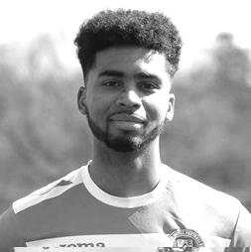
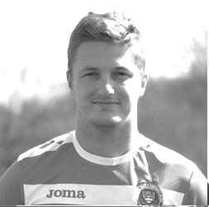
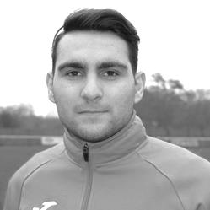
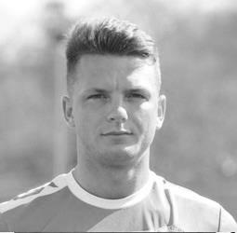
We start today’s summary with a 100 appearance milestone as Matt Tanton reached his century on Tuesday 7th March against Bedfont & Feltham here at High Road. Matt has been with us for a few seasons now, briefly appearing in our Reserve team in 2013/14 but being a first team regular since the opening day of the 2014/15 season when we won 2-0 at Farnham Town. He missed a few matches in that first season due to University commitments but has proven to be a very reliable left back in his time with the club, and every now and then gets forward to score a great goal! Congratulations Matt!

On 5th March Daryl Cooper-Smith celebrated his 27th birthday and of course also recently reached a milestone of his own in scoring 50 goals for the club. Daryl joined us in January 2015 and has been a regular on the score sheet ever since with 51 goals in 73 appearances. It is unfortunate that he completes his suspension today and this is the third time in a row we will have faced Hartley Wintney without him. At least he will be available for Tuesday’s League Cup Semi-Final.

Agi Panayiotou had his 22nd birthday just two days ago and made his debut the same day as Daryl, one that neither player will remember with much fondness as we were crushed 5-0 at home by Windsor that day, He had a brief spell at Chipstead but returned soon after and has now made 81 appearances with 11 goals for the club. A versatile midfielder, Agi appears most effective in the N’golo Kante role and his work rate is very impressive.

Finally, tomorrow Reisse Griffin celebrates his 27th birthday. Reisse joined us as a right winger, but has this season found himself playing left back, right back, and at CB Hounslow United, even centre-half! He is a very speedy individual and another of our players with a terrific work rate. He made his debut on the opening day of last season, as with our other two birthday boys, also against Windsor, and has clocked up 75 appearances and four goals so far. Congratulations all!

EL Records Premier Challenge Cup
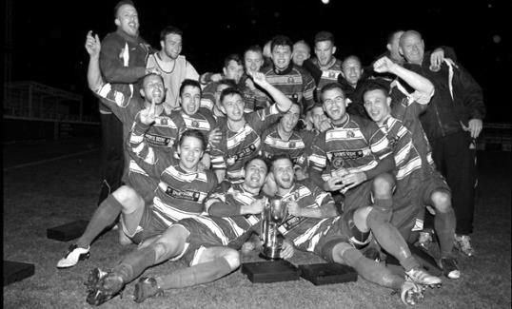
Quarter Finals
Windsor | 2-0 | Horley Town
Guildford City | 1-2 | Raynes Park Vale
Westfield | 4-1 | Camberley Town
Walton & Hersham | 1-3 | Epsom & Ewell
Semi Finals
Epsom & Ewell | 21/3 | Windsor
Raynes Park Vale | 21/3 | Westfield

Latest Results and Fixtures
Combined Counties League – Saturday 4th March
Camberley Town | 1-1 | Abbey Rangers
CB Hounslow United | 3-1 | Colliers Wood United
Chertsey Town | 1-4 | Badshot Lea
Epsom & Ewell | 1-1 | Walton & Hersham
Farnham Town | 0-0 | Hanworth Villa
Horley Town | 1-2 | Spelthorne Sports
Raynes Park Vale | 1-3 | Bedfont Sports
Sutton Common Rovers | 2-1 | AFC Hayes
Combined Counties League – Tuesday 7th March
Camberley Town | 0-1 | Sutton Common Rovers
Chertsey Town | 4-2 | North Greenford United
Epsom & Ewell | 4-1 | Bedfont & Feltham
Horley Town | 2-3 | Knaphill
Westfield | 1-1 | Spelthorne Sports
Combined Counties League – Wednesday 8th March
Bedfont Sports | 5-0 @B&F FC | Farnham Town
Colliers Wood United | 0-1 | Raynes Park Vale
Latest Results and Fixtures
Combined Counties League – Saturday 11th March
Abbey Rangers | 2-0 | Raynes Park Vale
AFC Hayes | 0-2 | Chertsey Town
Badshot Lea | 3-1 | Bedfont & Feltham
Bedfont Sports | 0-4 @ HTFC | Horley Town
CB Hounslow United | 1-2 | Spelthorne Sports
Colliers Wood United | 1-2 | North Greenford United
Guildford City | 2-3 | Camberley Town
Hartley Wintney | 3-1 | Westfield
Knaphill | 1-3 | Hanworth Villa
Walton & Hersham | 1-0 | Farnham Town
Windsor | 1-0 | Sutton Common Rovers
Combined Counties League – Tuesday 14th March
AFC Hayes | 2-2 | Spelthorne Sports
North Greenford United | 1-1 | Abbey Rangers
Walton & Hersham | 3-1 | Colliers Wood United
Westfield | 2-0 | Horley Town
Windsor | 1-1 | Bedfont & Feltham
Surrey Senior Cup Semi-Final – Wednesday 15th March
Guildford City | 1-2 | Woking
Combined Counties League – Wednesday 15th March
Bedfont Sports | 1-3 | Epsom & Ewell
Match to be played at Bedfont & Feltham FC
Combined Counties League – Saturday 18th March
Bedfont & Feltham | V | Colliers Wood United
Camberley Town | V | AFC Hayes
Chertsey Town | V | Raynes Park Vale
Epsom & Ewell | V | Hartley Wintney
Farnham Town | V | Knaphill
Hanworth Villa | V | Badshot Lea
Horley Town | V | CB Hounslow United
North Greenford United | V | Guildford City
Spelthorne Sports | V | Abbey Rangers
Sutton Common Rovers | V | Walton & Hersham
Westfield | V | Windsor
Combined Counties League – Monday 20th March
Sutton Common Rovers | V | Bedfont & Feltham
Combined Counties League Cup Semi-Finals – Tuesday 21st March
Epsom & Ewell | V | Windsor
Raynes Park Vale | V | Westfield

From behind the goal
Epsom & Ewell 1-1 Walton & Hersham
Combined Counties League - Premier Division - Saturday 4th March 2017

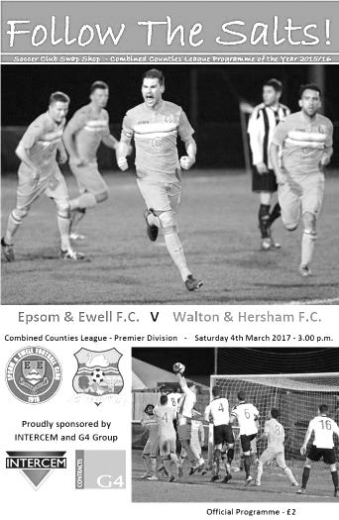
Honours even at High Road

Under leaden skies at our Chipstead home ground, two very even teams did battle in an important League meeting and deservedly finished with a point each.

Before commencing we had a minute's silence in respect of one of our regular players from the fifties Ron Ruffell, and it's at times like these I wonder what players like Ron would have made of the occasion. An attendance of 86 was one of our better ones, especially when considering the weather, yet back in the fifties there would have been more than that attending just to watch the Reserves, let alone the First team! Ron's high point whilst with our club was appearing in the 1954 Surrey Senior Cup Final when over 6,000 spectators watched us at Selhurst Park and an even larger crowd had watched us in the Semi-Final and replay. It truly is a different world these days!

However, it must be said that this match was worthy of a bigger audience. With the two teams meeting for the 52nd time in history and both well aware that they still had just an outside chance of catching Westfield for a potential second place, they gave everything, although the draw probably killed off any chances we of doing that.

We made just two changes to the starting eleven, one of which was an enforced one as Rob Hendry came in for the suspended Daryl Cooper-Smith, while Matt Ferdinando reclaimed his place in the starting eleven at the expense of Jason Nwachukwu who was on the bench. We started well enough and Jordan Gallagher had an early attempt on goal well blocked by the defence, although Ferdinando was probably in a better position. Gallagher got through on the left a few minutes later although his cross was cut out by visiting keeper Liam Beach and although he didn't gather the ball well and Reisse Griffin nipped in to steal the ball off him, he was wide out by this point and we were unable to craft a scoring opportunity.

The visitors were covering well with Rob Hendry being closely marked by the Walton Captain Lea Van Sullivan and they were beginning to cause us a bit of trouble down the flanks. In fact, that's exactly what gave the visitors the lead in the 27th minute after T.J. Nkoma made a good run down the right and as he got past Matt Tanton he was brought down with a number of our players in the vicinity. The referee appeared to think long and hard about the decision before awarding the penalty, which obviously annoyed some of our players. Billy Marshall then stroked the ball down the middle with

Michael Eacott unable to save it. Was it a penalty? You could argue that Nkoma was already falling to the ground, but those I spoke to around the ground who were closer than me had differing views both for and against the decision, so it would be harsh to be particularly critical here, just because the decision went against us.

In a match that looked very even it was quite possible that this might even be the only goal we would see today. The visitors were having slightly the better of the play at this point and a deep cross from the right wing was headed across our goal from a good position. Then right on half time Francois Gabbidon appeared to have broken through on goal but we recovered to make the tackle and we trailed by one at the half.

It must be remembered that we are unbeaten in the League at home since our opening match of the season and I fully expected our boys would come out and press for an equaliser at least. We had a bonus early in the second half when Hendry slipped the grasp of Sullivan and was pulled back, earning him a yellow card. He would have a bit more freedom as a result. Matt Ferdinando tried his luck with a well struck shot from 20 yards but Beach was able to make the catch. On the hour mark we nearly scored when Ferdinando did well on the right, putting Griffin through just inside of him. Now only Reisse will know whether he was shooting at goal or crossing but one thing is clear, it looked as though the ball was going in until Beach finger tipped it around the post.

We continued to press though and were finally level in the 67th minute from a clever Hendry pass to Gallagher who had time to take a shot before calmly finishing with a low shot beyond Beach. Jason Nwachukwu replaced Griffin on the right wing for the final twenty minutes and although a Walton free kick was headed well over the bar, we were back up the other end soon after and in the 81st minute from a Hendry free kick, Dan Dean headed the ball back across Beach and into the net, only to have his third goal in three games chalked off by an offside flag. Minutes later Nwachukwu and Matt Farrell linked up well but Farrell's shot just took a deflection on its way through to a grateful Beach.

Could we have done better? It could be argued that we played really well over at Stompond Lane in winning our League Cup Quarter-Final, but the opposition had a stronger defence out. If I were being critical we really do need to do more on the dissent cards of which there were three more. Of course there were some frustrating decisions at times, but we have some big matches left this season and it would be very disappointing if some of our players were to miss out because of a lack of discipline.

Ultimately, this was a good advert for Combined Counties League football, even if the result, identical to the return League match in October, didn't really help either of us that much. However, with plenty of the season remaining, a top four spot is still well within our grasp and we take our 8 match unbeaten record into Tuesday's home meeting with Bedfont & Feltham confident that we can finish the season strongly.

Epsom and Ewell: Michael Eacott, Adam Heagney, Matt Tanton, James Taylor, Dan Dean ©, Savvas 'Agi' Panayiotou, Jordan Gallagher, Matt Farrell, Rob Hendry,
Matt Ferdinando, Reisse Griffin

Subs: Jason Nwachukwu for Griffin (72)

From behind the goal
Epsom & Ewell 4-1 Bedfont & Feltham
Combined Counties League - Premier Division - Tuesday 7th March 2017

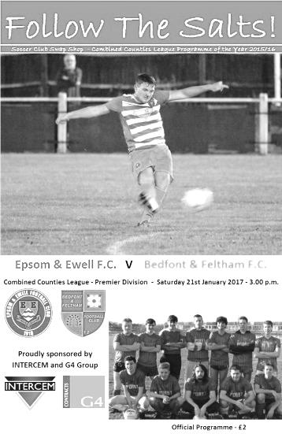
Lacklustre Epsom secure the points in the end

A first look at the scoreline would appear to indicate that we had registered another comfortable home win against a team at the foot of the table but don't be fooled here. The visitors put a lot into this match and two late goals gave the score an unfair gloss after they came perilously close to equalising in the second half.

Mindful of the fact that two of our players would be suspended for the upcoming League Cup Semi-Final, Glyn rested both Dan Dean and Matt Ferdinando for this match and I can report that injuries permitting we will now have a completely full squad to choose from on that night. In their places came Craig Hastings and Jason Nwachukwu while Rob Hendry continued up front as Daryl Cooper-Smith continued his suspension.

It was a strange night for our striker as he scored twice yet on another day could have had four as he also hit both posts with powerful efforts. We would also hit the bar in this match but we didn't start that well against a team that had arrived in ones and twos due to trouble on the M25 and they took the lead in the 10th minute. A ball across our defence found one of their players in space and he cut inside the covering Matt Tanton and fired at goal where Michael Eacott half blocked the shot although we didn't react and the loose ball was fired into the net from close range by Shakeel Morris.

To say our Management were unimpressed with this state of affairs was an understatement but our boys picked up the pace and were level within four minutes. Jordan Gallagher delivered one of those perfect free kicks from wide out; the sort that if left alone would creep in at the far post, which meant that visiting keeper Ashley Davy was unable to commit to the near post run from Hendry and he got the faintest of touches to the ball with his head leaving it nestling in the far corner.

Gallagher was just over the bar with a free kick after he had been brought down just outside the area but we were ahead in the 20th minute after Agi Panayiotou hit a swerving drive from the edge of the area that deceived Davy and flew into the net. We were into our stride now and a deep ball in was headed back to Hendry who let fly with a low shot from the edge of the area that thudded off the foot of Davy's left hand post and away to safety. In fact we were getting a lot of shots in and in the 31st minute

Reisse Griffin had a try from over on the right which deflected off a defender and looped up and over Davy, clipping the crossbar on the way out for a corner. A couple of minutes later Nwachukwu was next to try his luck but Davy parried his low drive to keep his team in the match.

Gallagher broke down the left and reached the bye line before cutting the ball back just behind the advancing Matt Farrell but Griffin at the far post then crossed the ball back in where Hendry was just wide with a downward header and before the half time whistle there was time for both Gallagher and Panayiotou to have another shot on goal but neither were able to keep their strikes on target.

As we came out for the second half it appeared just a matter of how many we would score, but to their credit Bedfont & Feltham started to push us back. They had found space on the right, cutting back inside Tanton and squaring the ball for what appeared a tap in but Adam Heagney made a great interception to protect the lead. A long shot came in but Eacott was able to get down to make the save and general pressure continued but to be honest the visitors were lacking a cutting edge and much of their possession was wasted.

Tanton picked up a yellow card on his hundredth appearance for the club as the pressure continued. Our wingers Griffin and Gallagher had switched wings for a while but this achieved nothing today and ultimately it required the introduction of Alex McKay from the bench to enable us to take control of the match once again. Gallagher, by now back on the right wing ran across the edge of the area before setting up Panayiotou with a clever back heel but the shot was dragged just wide of the far post.

Then Hendry almost took advantage of a defensive error as he was in on goal but his low shot smacked the right hand post this time and flew away to safety. With four minutes remaining we earned another free kick on the corner of the penalty area after Gallagher was brought down. From an identical angle to the free kick we had scored from in the first half, we had the identical result as Hendry ran to the near post once again and his header flew into the top corner of the goal to ease any nerves there may have been amongst the supporters. In the second minute of injury time we scored a fourth goal when Alex McKay's long throw was missed by everyone and as it bounced up off the ground, Farrell met it with a close range header, giving Davy no chance.

So the unbeaten League home record extends to seventeen matches after this win and we move up to fourth place too, with other results going well for us. However, you couldn't help but feel sorry for the visitors who probably should have been out of it by half time, but kept going, providing plenty of concern for home players and supporters alike in the second half and I'm sure that performances like this will ensure they bounce straight back up to Step Five after their inevitable relegation later this season.

Epsom and Ewell: Michael Eacott, Adam Heagney, Matt Tanton, James Taylor,
Craig Hastings, Savvas 'Agi' Panayiotou, Jordan Gallagher, Matt Farrell (c),
Rob Hendry, Jason Nwachukwu, Reisse Griffin

Subs: Alex McKay for Tanton (79), Rhys North for Heagney (91),
Matt Smith for Nwachukwu (91)

Hartley Wintney - History
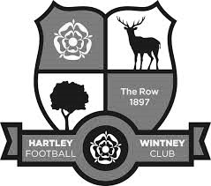
Hartley Wintney Football Club, as our records indicate, was founded in 1897 and played in an area situated at Causeway Farm, not far from our present headquarters and adjacent to the village's golf and cricket clubs. From stories told by the older members, and from the old club records, it appears that the village side competed well against local opposition, despite the facilities not being of today's standard, with only a horse trough or the pond to remove the heavy mud from a sub-standard pitch. In 1953, the club moved to its present ground in Green Lane, known as 'The Memorial Ground'. A pavilion was erected and the team played in the Basingstoke and Aldershot Leagues.

In 1973, Glynn Howells (a former Epsom & Ewell goalkeeper and father of Tottenham player David Howells) was appointed Manager and, with an influx of players, Hartley Wintney FC was put firmly on the local football map. In his six year reign, the team managed to win the Aldershot Senior League three times in succession and, on a night to remember, the Aldershot Senior Cup. In 1975, the facilities were once again improved, when a bar was built within the pavilion.

After several seasons in the ASL, Hartley applied for the Combined Counties League - a competition that replaced the Surrey Senior League - and were granted admittance. After the first couple of seasons and two changes of management, the club appointed Ian Bedford as Manager. Once again an influx of senior players gave Hartley the success they deserved. Within his three years in management, they gained trophies including the League Title (1982-1983) and Runners Up (1981-1982), Aldershot Senior Cup Winners (1980-1981), George Allen Cup Winners (1981-1982). They were also Runners Up in the League Cup (1982-1983) and Aldershot Senior Cup (1981-1982).

During this period a new Club House, which is our present H.Q., was opened by ex-Chelsea star Peter Osgood. These facilities, together with the recently improved dressing rooms, are ranked as amongst the very best in the League. David Willoughby, the then Secretary/Treasurer, and Bill Mitchell, Chairman, spent exceptional hours in the embryo stages of this venture - one of the bars is now named 'The David Willoughby Room'.

Hartley Wintney FC has come a long way, from village side in every sense of the term, to today's 7 days a week modern Football Club, but it’s hard working committee has succeeded in retaining a village atmosphere. In recent years, the club has invested in new floodlights costing £40,000, completely rebuilt the changing rooms at a cost of over £100,000, and erected a modern stand with seating. The Club is indebted to the volunteer workers who continue to keep the Club afloat.

The club gained promotion from Division One of the Combined Counties League in 2007-

08. But 08/09 began poorly and ended in relegation by a narrow margin. The 2011-12 season under manager Neville Roach, Assistant Mick Wollen and Coach Scott Tarr was a notable one for the club as they again achieved promotion back to the Combined Counties League Premier Division and also had a fine F.A. Cup run that took them to the third qualifying round, going out in the Third Qualifying Round at Conference South near neighbours Basingstoke Town.

The euphoria of the cup run and promotion was dampened at the end of the 2011-12 season when the coaching staff left to take the managerial role at Southern League Thatcham Town. The entire squad bar two players left, and so new manager Dave Tuttle was faced with the huge task of rebuilding a squad competitive enough for the CCL Premier. A reasonably good squad was assembled, but events behind the scenes and within the playing squad added to the pressure following a string of poor results. It led to a second change in the management setup of the first team in less than 4 months, with 24 year-old Ben Dillon given his first managerial position.

Once again there was an almost total outflow of players, and Ben and his staff set about again rebuilding the squad, but by this time with Hartley well and truly set adrift at the bottom of the table. Clearly something of a baptism of fire for the young manager, but his enthusiasm, belief and the introduction of a talented group of new players quickly restored the spirit around the whole club. Hartley Wintney's place in the CCL Premier was secured after a truly remarkable second half of the season thanks to the belief and commitment of the new squad and the coaching staff.

In 2013-14, the First Team consolidated its position in the CCL Premier division, while acheiving the club's best ever success in the FA Cup by reaching the 4th Qualifying Round.

Season 2014-15... At the end of the season, Ben Dillon took the decision to step down to devote more time to family and work commitments. First Team coach was appointed as Joint First Team Manager along with Anthony Millerick.

The football club has established a clear line of progression for young players with the establishment of an U18 Youth setup playing in the Southern Youth League, and a Reserve team playing in the Suburban League. The senior club has also moved to improve links with the Junior club. These factors are huge positives which the committee hopes will greatly improve the club's chances of continuing to play and maintain their position at an elevated level of amateur football.

During the 2015/16 campaign, under the guidance of newly appointed joint managers Daniel Brownlie & Anthony Millerick, Hartley created club history by reaching the 4th round of the FA Vase improving on the previous record of the 3rd round set in 1992. It was also a year of celebration as #TheRow were crowned CCL Premier Division Champions after finishing on 106 points. Clearly in 2016/17 they will be trying to pass that mark.

Ron Ruffell 1932-2017
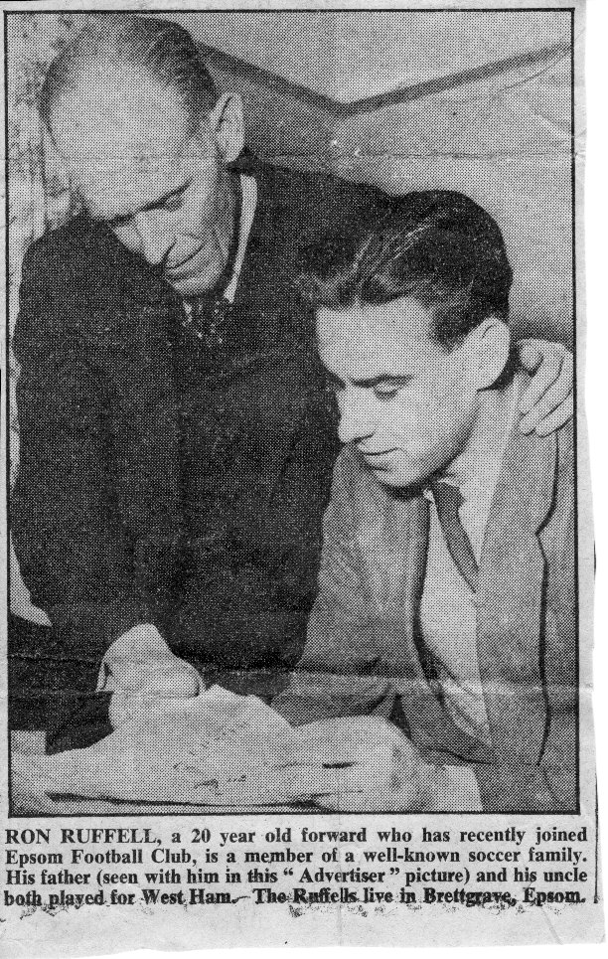

At our most recent Saturday home match against Walton & Hersham we held a minute’s silence in respect of Ron Ruffell, who passed away in Scotland on Monday 27th February at the age of 84.

Ron was a member of our 1954 Surrey Senior Cup Final team and was a fine left winger, although he wasn’t the first from his family to play for our club.

In fact, the Ruffell family have a large part to play in our club history, and also that of another bigger club, West Ham United.

The story actually starts with his uncle Jim who was a very good player in the twenties and a winger, like Ron. Born in Doncaster on 8th August 1900, Jimmy Ruffell played for West Ham United in the 1923 F.A. Cup Final against Bolton Wanderers and held their club appearance record with 548 until a certain Bobby Moore came along and broke it in 1973. Even with more games played in this day and age, he remains in sixth place on the all-time list. He also scored 166 times for the Hammers and played six games for England before retiring to run a pub in Stanford-le-Hope in Essex.

His brother William George Ruffell, Ron’s father was born in Poplar, East London on 29th April 1905, although he failed to break into the West Ham first team, and after two years he moved to play for Nelson, at the time a Football League club in the North West, plying their trade in the Third Division North. He made twelve appearances for them in 1927/28 but left following their relegation.

Bill had trials with Stockport County and Crewe Alexandra before moving into non-league football, but he didn’t actually play for us until Boxing Day 1932, as he more frequently turned out for his works side at the Manor Hospital in Epsom. In fact, his time with us was sporadic, playing only four games in four seasons, making his last appearance in a friendly against a Tottenham Hotspur XI on 22nd April 1936. However, he did also play frequently for the wartime Epsom Town side, where I have been able to find 24 goals in 25 appearances so far. The last match I can trace before an injury ended his career was in the Surrey Senior Cup Final of 1944 when Epsom Town were defeated 3-1 by Tooting & Mitcham United at Sandy Lane.

1932 was significant for another reason as Ron entered the world on 29th September. Unsurprisingly, the young lad was quite good at football. However, chastened maybe by

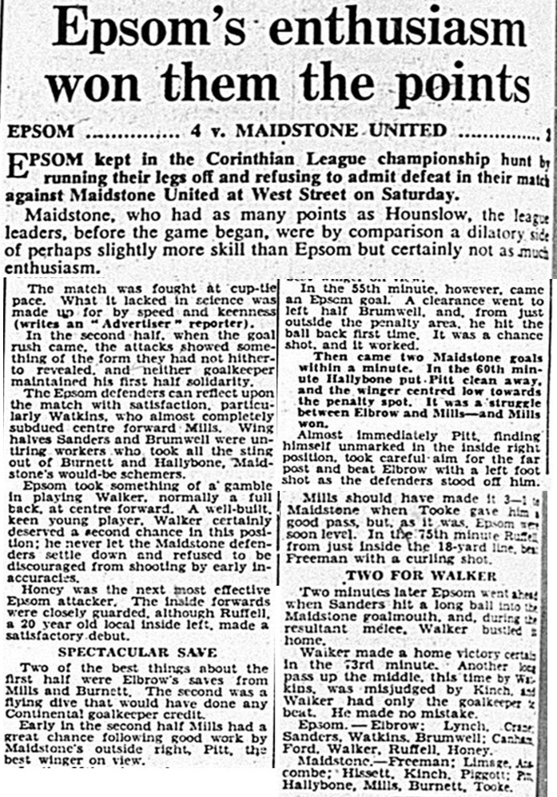
Ron Ruffell’s debut 7th February 1953 – reported by Epsom Advertiser

his experience at Upton Park, his father advised him against signing a professional contract there as it gave him no career prospects after football. He made his Epsom debut at the age of 20 in a 4-2 home win over Maidstone United on 7th February 1953 and scored one of the goals.

He only played occasionally that season but made 28 appearances in 1953/54 and scored eight times, including one that went into the net and out of a hole against Hounslow in the League Cup. Just seven days later, he did exactly the same thing for the Reserves. Fortunately both goals were awarded!

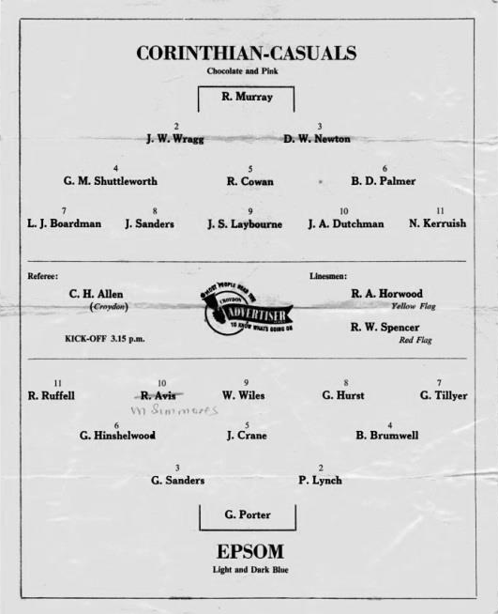
There were family similarities. Like his uncle, Ron wore the number 11 shirt, a sign of the outside-left, or left-winger these days. Even when the great left-winger Bobby Avis joined the club from Isthmian League side Hendon, Ruffell stayed on the flank while Avis moved to inside left instead. Like his father, Ron also played in a Surrey Senior Cup Final, this time in front of 6.159 at Selhurst Park, but he was also on the losing side, this time 2-0 to Corinthian Casuals (see programme below).

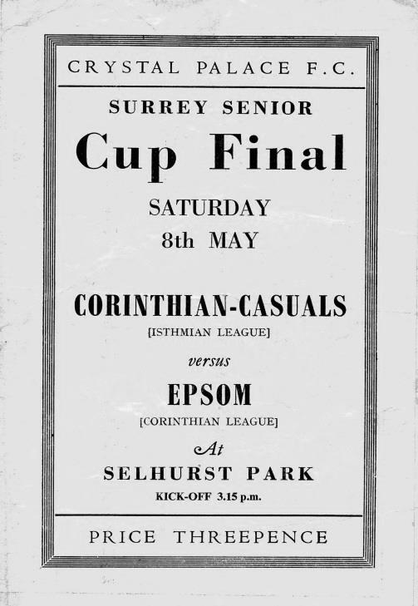
By that time, the family’s connection with Epsom Football club had grown stronger, as on 20th February 1954 Ron married Liz Sperring, daughter of one of the club founders and star players, Reg. It was great to see Liz was at the Walton match.

In July of 1954 it was reported that Ron would be leaving the club as he was concerned about the number of injuries he was picking up, which was affecting his work. By October he was training with us again, although he only made eight starts that season,

with his final match for the club coming in a 4-1 defeat at Yiewsley on 22nd January 1955. His made 40 appearances for us, scoring ten goals in that time.

He left for Leatherhead in the summer of 1955 before joining Dorking in January 1956, although was back in a Leatherhead shirt in April 1956 when they played a challenge match with Epsom. Upon their election to the Corinthian League in the summer of 1956 he joined Dorking again and played against Epsom on the Boxing Day, but Epsom won 9-0! However, he remained with Dorking for a few seasons and got revenge in March of 1960 when he made three of the goals in Dorking’s 4-0 win at West Street, not long before we won the Corinthian League Memorial Shield.

Ron’s family sponsored a match a few years ago, but regrettably it was postponed and Ron never did get to make that final visit to watch us. I’m glad that many of his family were able to attend two weeks ago. I wonder what he would have made of it all though with West Street long gone and even Dorking’s Meadowbank site in the process of being rebuilt, having been flattened recently with no trace remaining of the original ground except the turnstiles. Hardly a crowd to speak of compared to the days when we used to get a few hundred in just to watch the Reserves, although I’m sure he would be happy to see that we were still in existence after all these years, especially after the recent news about Dorking’s imminent closure. Rest in peace Ron!

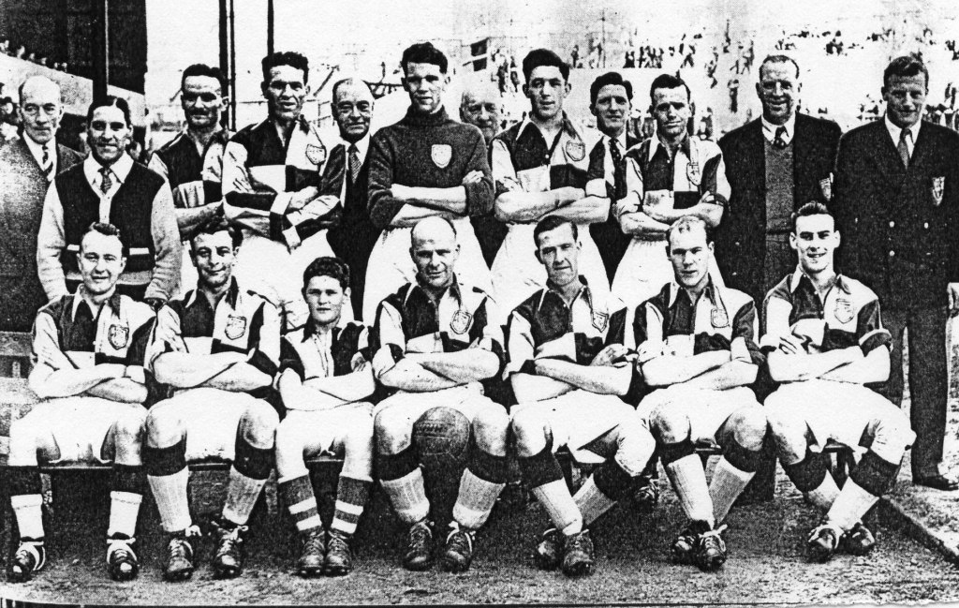
The 1954 Surrey Senior Cup Final team
Line Up - Back Row: L.Stapeley (Committee), Fred Aldred (Trainer), Brian Brumwell, Jim Crane, Alderman G.C.A. Mann (President), Geoff Porter, Grant Sherman (Chairman), Gordon Sanders, Ron Holloway, Glyn ‘Chick’ Hinshelwood, Ernest Fletcher (Secretary), Johnny Hitchcock (injured)

Front Row: Gordon Tillyer, Gordon Hurst, Roy Oldaker (Mascot), Pat Lynch (Player / Coach), Bill Wiles, Micky Simmonds, Ron Ruffell

Club Records - 18th March
Date | Day | Competition |  | Opponents |  | Scorers
18/03/33 | Sat | London League | H | Cray Wanderers | 4-0 | L.Marlow (2), L.Graves, J.Gillespie
18/03/50 | Sat | Friendly | H | Fulham 'A' | 3-3 | D.Kennell, L.Birbeck, T.Wright
18/03/61 | Sat | Corinthian League | A | Horsham | 0-5
18/03/67 | Sat | Athenian League 2 | A | Eastbourne United | 0-0
18/03/72 | Sat | Athenian League 2 | A | Hemel Hempstead Town | 1-1 | C.Roots
18/03/78 | Sat | Isthmian League 2 | A | Epping Town | 2-0 | R.Parkin, J.Fascione
18/03/86 | Tue | Isthmian League  Premier Division | A | Worthing | 3-2 | R.Lewis (2), R.Kidd
18/03/93 | Thur | Southern Combination Cup 1 | H | Banstead Athletic | 1-0 | D.Meyer
18/03/95 | Sat | Isthmian League 3 | A | Kingsbury Town | 0-1
18/03/00 | Sat | Isthmian League 3 | H | Aveley | 0-0
18/03/03 | Tue | Isthmian League 1s | H | Corinthian Casuals | 0-0
18/03/06 | Sat | Isthmian League 2 | A | Clapton | 3-1 | M.Tacey, P.N'gbale, C.Read
18/03/14 | Tue | Combined Counties  League Cup QF | A | Wembley | 0-2
Historical Decades
Date | Day | Competition |  | Opponents |  | Scorers
90 years ago – Epsom Town F.C.
19/03/27 | Sat | Surrey Senior League | H | Egham | 1-1 | R.Marlow
80 years ago – Epsom F.C.
13/03/37 | Sat | Friendly | A | Grays Athletic | 0-2
70 years ago – Epsom F.C.
15/03/47 | Sat | London League | H | Leavesden | 1-4 | F.Taylor
60 years ago – Epsom F.C.
16/03/57 | Sat | Corinthian League | H | Yiewsley | 2-1 | D.Hermitage, P.Freeman
50 years ago – Epsom & Ewell F.C.
18/03/67 | Sat | Athenian League 2 | A | Eastbourne United | 0-0
40 years ago – Epsom & Ewell F.C.
15/03/77 | Tue | Athenian League 1 | A | Erith & Belvedere | 1-1 | P.Weller
30 years ago – Epsom & Ewell F.C.
17/03/87 | Tue | Isthmian League 1 | A | Grays Athletic | 2-4 | D.Jones (2)
20 years ago – Epsom & Ewell F.C.
15/03/97 | Sat | Isthmian League 3 | A | Northwood | 1-2 | N.Cawthorne
10 years ago – Epsom & Ewell F.C.
17/03/07 | Sat | Combined Counties  Premier Division | A | Cove | 2-2 | S.Hatton (2)

History Corner - 18th March
90 years ago this week we drew with Egham at West Street. We were going to win the League at a canter and would also add the League Cup anyway so why does this result matter, you might think, but this draw was significant as it ended our club record run of 20 consecutive League and League Cup home wins. The fact was that we so nearly made it 21.

In a tight match Reg Marlow had put us ahead in the 85th minute but the visitors poached a late equaliser and we had to settle for a point. It didn’t matter in the grand scheme of things and that particular winning record remains to this day. (see programme pictured)

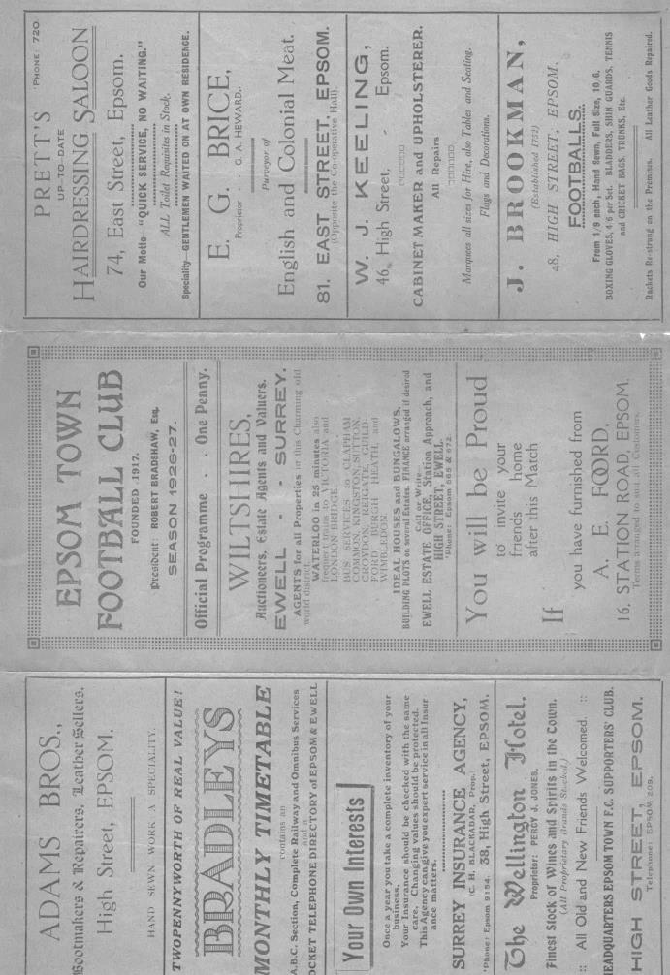
50 years ago today we secured a 0-0 draw at leaders Eastbourne United in an Athenian League match, having already beaten them 5-2 at home earlier in the season. Eastbourne were at the time being Managed by none other than future England Manager Ron Greenwood and at the end of the season their promotion was assured despite their blips against us.

31 years ago today things were looking grim as our brief spell in the Isthmian League Premier Division was coming to an end. We hadn’t won away from home all season and travelled to Worthing more in hope than expectation. Events appeared to be taking their expected course as we trailed early and then scored a 40 yard own goal as Jimmy Richardson lobbed Peter Burdett with a back pass. Somehow our Manager Alan Webb sparked a second half turnaround and we stormed back to win 3-2 with a couple of goals from Robin Lewis and one from Ricky Kidd.

We still went down that season and this was one of only two away wins we would get all season, the other coming at Farnborough Town in the April and we were adrift by four points in the end, never to return.

20 years ago this week we made our fifth and final visit to Chestnut Avenue for a League match against Northwood and led through Nick Cawthorne but the opposition were level by half time and won 2-1. Cawthorne came into the First team after a spell with the Epsom & Ewell Supporters F.C. and was a home grown product who used to stand on the bank with me at West Street. He even took part in a sponsored walk to Southall in December 1987 while still a regular supporter!!

Centre page for results

Centre page for results

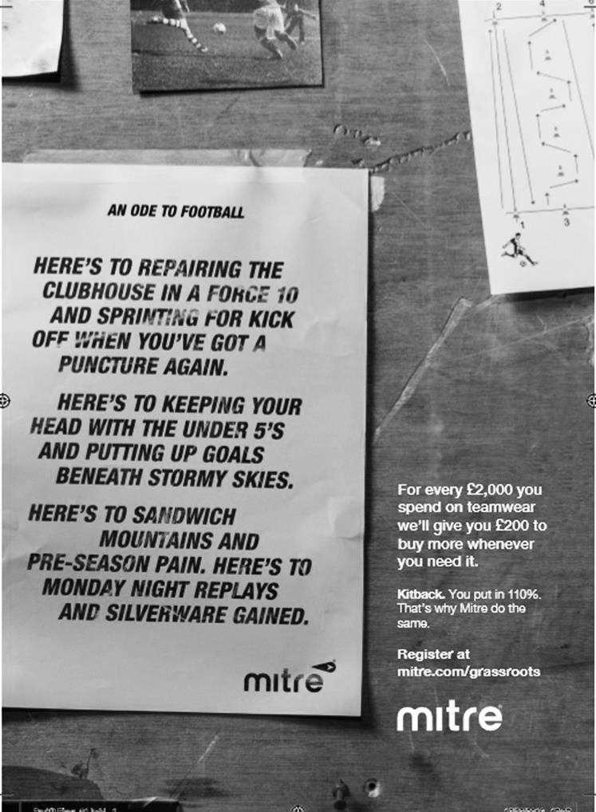

My Club Betting
We can now announce that Epsom & Ewell F.C.
now have our own betting site!

If you like to have a bet, this is most definitely for you.

In conjunction with MyClubBetting.com you can now access all the regular markets that you might do regularly with just a click on our website.

But why would you do this? Many of you already might have apps that you currently use.

The main reason is that you would benefit the club by doing so, but at the same time would not lose out yourselves. Their odds are at least comparable and in many cases better than the other bookmakers out there and by registering with us, the club would make 20% of any cumulative losses and with enough usage, we would qualify for other fairly substantial club benefits.

If you win the bet that you place, that is fantastic news, but whichever company you use currently would keep 100% of any losses. This way our club can receive a nice lump sum in the event that you are unlucky.

For example. If we have 20 people signed up and they lost £25 over the month each, our club would receive £100 back out of the £500 lost.

So just visit: https://eefc.myclubbetting.co.uk/ and join the club, or just visit the link on our main website!

Match and Ball Sponsorships – 2016/17
Opponent | Date | Match Sponsor | Ball Sponsor
Gravesham Borough | 07/08/16 | Club President - Stella Lamont
Gravesham Borough | 07/08/16 | Relocation Committee Member - Mike Lovett
CB Hounslow United | 16/08/16 | EEFC Management Committee
Abbey Rangers | 23/08/16 | Steve & Geoff Dyke
Horley Town (11.30am) | 29/08/16 | In Memory of Chris Henry
Abbey Rangers (LC) | 06/09/16 | Paul Merritt
Camberley Town | 10/09/16 | Building Shop Ltd
Knaphill | 24/09/16 | EEFC Holding Company Director – Pete Lumm
Bridon Ropes (FAV) | 22/10/16 | George and Joseph Saunders
Sutton Common Rovers | 08/11/15 | Alex McKay Senior
Abbey Rangers (FAV) | 13/11/16 | EEFC Holding Company Director – Dave Ellins
Windsor | 15/11/16 | In Memory of Wally Dyke
Bedfont Sports | 19/11/16 | John Bonner
AFC Hayes | 26/11/16 | Jack Jarman
Chipstead (SSC / DWT) | 06/12/16 | Trevor Stotten
Hanworth Villa | 13/12/16 | Roger and Carol Farrell
Chertsey Town | 17/12/16
Raynes Park Vale (11.30am) | 27/12/16 | In memory of Dave and Liz Marshall
Spelthorne Sports | 07/01/17 | Building Shop Ltd
Guildford City (SSC) | 10/01/17 | Super Six Winner – Rita Christian
Guildford City | 17/01/17
Badshot Lea | 04/02/17
Westfield | 18/02/17 | Tony Coome
Walton & Hersham | 04/03/17 | Super Six Winner – Rita Christian
Bedfont & Feltham | 07/03/17 | Programme Editor - Richard Lambert
Hartley Wintney | 18/03/17
Windsor (LC SF) | 21/03/17 | In memory of Bob Bexley
Farnham Town | 25/03/17 | In memory of Jean Bexley
Colliers Wood United (1pm) | 14/04/17
North Greenford United | 22/04/17 | Club President - Stella Lamont
For League, League Cup and Surrey Senior Cup Matches:
Match sponsorship - £40.00 Match ball sponsorship - £25.00. Combined £55.00.
For F.A. Cup and F.A. Vase matches:
Match sponsorship - £50.00 Match ball sponsorship - £30.00. Combined £65.00.

Sponsorship includes: (x2 for match, x3 for match and ball)

Admission, programmes, hospitality and advertising and mascot for the day (if required).
If you are interested, just speak to a Committee Member, or drop me an email at: richard.c.lambert@gmail.com

We also thank our Sponsors INTERCEM and G4 Group

Player Sponsorship
Here is the current list for the 2016/17 season showing all of our players and Management that are available for sponsorship.

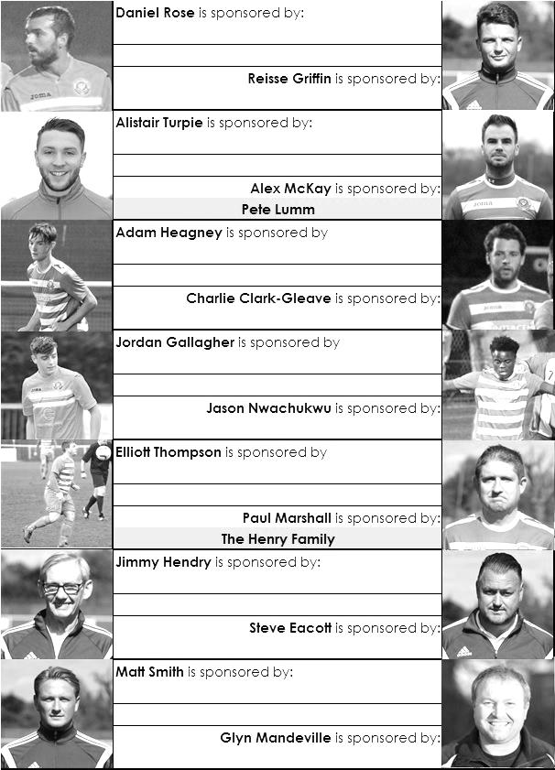

Sponsorship costs just £40 and it is easy to do. Just select a player who has not been previously sponsored and let a Committee Member know that you would like to sponsor them. Beware though. Until we have received the money it is possible for someone to jump in front of you, so don’t delay, sponsor today!
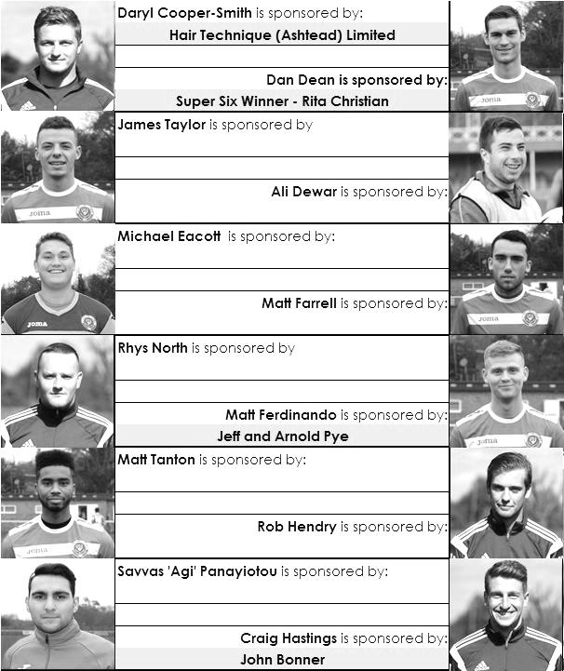

Cherry Red Records Combined Counties League
Premier Division FORM Table – Last 9 Matches
Here is the current state of play based on every club’s last nine League matches. If we keep doing well, the table stays in the programme!

inc Wednesday 15th March | P | W | D | L | F | A | Pts | GD
Hartley Wintney | 9 | 8 | 1 | 0 | 34 | 9 | 25 | +25
Epsom & Ewell | 9 | 7 | 2 | 0 | 22 | 8 | 23 | +14
Walton & Hersham | 9 | 6 | 2 | 1 | 19 | 8 | 20 | +11
Sutton Common Rovers | 9 | 6 | 0 | 3 | 15 | 7 | 18 | +8
Hanworth Villa | 9 | 5 | 3 | 1 | 14 | 8 | 18 | +6
Westfield | 9 | 5 | 2 | 2 | 21 | 12 | 17 | +9
Abbey Rangers | 9 | 4 | 4 | 1 | 14 | 10 | 16 | +4
Spelthorne Sports | 9 | 4 | 3 | 2 | 19 | 12 | 15 | +7
Chertsey Town | 9 | 5 | 0 | 4 | 14 | 18 | 15 | -4
Camberley Town | 9 | 4 | 2 | 3 | 16 | 18 | 14 | -2
Windsor | 9 | 3 | 4 | 2 | 16 | 9 | 13 | +7
North Greenford United | 9 | 4 | 1 | 4 | 15 | 14 | 13 | +1
Badshot Lea | 9 | 4 | 1 | 4 | 21 | 21 | 13 | 0
Bedfont Sports | 9 | 3 | 2 | 4 | 15 | 16 | 11 | -1
Farnham Town | 9 | 3 | 2 | 4 | 14 | 16 | 11 | -2
CB Hounslow United | 9 | 3 | 1 | 5 | 9 | 13 | 10 | -4
Knaphill | 9 | 3 | 1 | 5 | 13 | 18 | 10 | -5
Guildford City | 9 | 2 | 1 | 6 | 11 | 17 | 7 | -6
Raynes Park Vale | 9 | 2 | 1 | 6 | 6 | 17 | 7 | -11
AFC Hayes | 9 | 1 | 3 | 5 | 9 | 17 | 6 | -8
Horley Town | 9 | 1 | 1 | 7 | 12 | 20 | 4 | -8
Colliers Wood United | 9 | 1 | 1 | 7 | 11 | 22 | 4 | -11
Bedfont & Feltham | 9 | 1 | 1 | 7 | 12 | 30 | 4 | -18

CCL Premier Division Club Directory
ABBEY RANGERS Telephone: 01932-422962 - Ground: Addlestone Moor, Addlestone, Surrey KT15 2QH - Colours: Black & White Stripes/Black/Black

A.F.C. HAYES Telephone: 0208-845-0110 - Ground: Farm Park, Kingshill Avenue, Hayes, Middx. UB4 8DD - Colours: Blue and White Stripes/Blue/Blue

BADSHOT LEA Telephone: 01252-320385 - Ground: Ash United FC, Shawfield Stadium, Youngs Drive, Shawfields Road, Ash, Hampshire. GU12 6RE - Colours: Claret/White/Claret

BEDFONT & FELTHAM Telephone: 0208 890 7264 - Ground: The Orchard, Hatton Road, Bedfont, Middx TW14 9QT - Colours: Yellow & Blue/Blue/Blue

BEDFONT SPORTS Telephone: 0208-831-9067 - Ground: Bedfont Sports Club, Hatton Road, Bedfont, Middx TW14 8JA - Colours: Red & Black Hoops/Black/Red & Black Hoops

CAMBERLEY TOWN Telephone: 01276-65392 - Ground: Krooner Park, Wilton Road, Camberley, Surrey. GU15 2QW - Colours: Red & White Stripes/Blue/Red

CB HOUNSLOW UNITED Telephone: 0208 890 7264 - Ground: The Orchard, Hatton Road, Bedfont, Middx TW14 9QT - Colours: Green/Black/Green

CHERTSEY TOWN Telephone: 01932-561774 - Ground: Alwyns Lane, Chertsey, Surrey. KT16 9DW - Colours: Royal Blue & White Stripes/Royal Blue/Royal Blue

COLLIERS WOOD UNITED Telephone: 0208-942 8062 - Ground: Wibbandune Sports Ground, Robin Hood Way, Wimbledon. SW20 0AA - Colours: Blue & Black Stripes/Black/Black
EPSOM & EWELL Telephone: 01737-553250 - Ground: Chipstead FC, High Road, Chipstead, Surrey. CR5 3SF - Colours: Royal Blue & White Hoops/Royal Blue/Royal Blue

FARNHAM TOWN Telephone: 01252-715305 Ground: Memorial Ground, Babbs Mead, West Street, Farnham, Surrey. GU9 7DY Colours: - Claret & Sky Blue /White/ Claret & Sky Blue

GUILDFORD CITY Telephone: 01483-443322 - Ground: The Spectrum, Parkway, Guildford, Surrey. GU1 1UP - Colours: Red & White Stripes/Black/Black

HANWORTH VILLA Telephone: 0208-831-9391 - Ground: Rectory Meadows, Park Road, off Hounslow Road, Hanworth, Middlesex. TW13 6PN - Colours: Red & White Stripes/Black/Black

HARTLEY WINTNEY Telephone: 01252-843586 - Ground: Memorial Playing Fields, Green Lane, Hartley Wintney, Hants RG27 8DL - Colours: Orange & Black/ Orange /Orange

HORLEY TOWN Telephone: 01293-822000 - Ground: The New Defence, Anderson Way, Court Lodge Road, Horley, Surrey. RH6 8SP - Colours: Claret & Sky Blue/Claret/Claret

KNAPHILL Telephone: 01483-475150 - Ground: Brookwood Country Park, Redding Way, Lower Guildford Road, Knaphill, Surrey. GU21 2AY - Colours: Red/Black/Red

NORTH GREENFORD UNITED Telephone: 0208 422 8923 - Ground: Berkeley Fields, Berkeley Avenue, Greenford, Middx UB6 0NX - Colours: Royal Blue & White/Royal Blue/Royal Blue

SUTTON COMMON ROVERS Telephone: 01932-866386 - Ground: Sutton United FC, Gander Green Lane, Sutton, Surrey SM1 2EY - Colours: Yellow/Black/Black

RAYNES PARK VALE Telephone: 020-8540-8843 - Ground: Prince Georges Playing Field, Grand Drive, Raynes Park, London. SW20 9NB - Colours: Blue/Blue/Red

SPELTHORNE SPORTS Telephone: 01932-961055 - Ground: Spelthorne Sports Club, Staines Road, Ashford Common, Ashford, Middx. TW15 1RY - Colours: Light & Dark Blue/Dark Blue/Light Blue

WALTON & HERSHAM Telephone: 01932 245263 - Ground: Stompond Lane, Walton on Thames, Surrey KT12 1HF - Colours: Red/Red/Red

WESTFIELD Telephone: 01483-771106 - Ground: Woking Park, Kingfield Road, Woking, Surrey. GU22 9BA - Colours: Yellow/Black/Black

WINDSOR Telephone: 01753-860656 - Ground: Stag Meadow, St Leonards Road, Windsor, Berks SL4 3DR - Colours: Red/Red/Red

First Eleven Appearances 2016/17 - (max 47)
Name | Debut | 2016/17 |  |  |  | Career Totals
 |  | App | Sub | Total | Goals | App | Sub | Total | Goals
CLARK-GLEAVE Charlie* | 23/08/2016 | 3 | 2 | 5 | 0 | 3 | 2 | 5 | 0
COOPER-SMITH Daryl | 03/01/2015 | 30 | 5 | 35 | 31 | 60 | 13 | 73 | 51
DEAN Dan | 02/08/2014 | 34 | 2 | 36 | 2 | 102 | 6 | 108 | 4
DEWAR Ali | 29/10/2011 | 0 | 5 | 5 | 0 | 55 | 40 | 95 | 10
EACOTT Michael | 02/08/2014 | 39 | 0 | 39 | 0 | 124 | 1 | 125 | 0
FARRELL Matt | 02/08/2014 | 43 | 0 | 43 | 16 | 129 | 4 | 133 | 34
FERDINANDO Matt | 20/09/2014 | 26 | 8 | 34 | 9 | 79 | 14 | 93 | 23
GALLAGHER Jordan | 07/08/2016 | 33 | 12 | 45 | 11 | 33 | 12 | 45 | 11
GRIFFIN Reisse | 08/08/2015 | 37 | 6 | 43 | 2 | 65 | 12 | 77 | 4
HASTINGS Craig | 08/08/2015 | 29 | 7 | 36 | 2 | 66 | 11 | 77 | 2
HEAGNEY Adam | 16/08/2016 | 32 | 7 | 39 | 0 | 32 | 7 | 39 | 0
HENDRY Rob | 08/08/2015 | 32 | 9 | 41 | 10 | 62 | 20 | 82 | 22
MCKAY Alex | 20/12/2008 | 18 | 6 | 24 | 3 | 126 | 36 | 162 | 11
NEALE Tom* | 13/10/2015 | 6 | 5 | 11 | 7 | 22 | 24 | 46 | 17
NORTH Rhys | 16/08/2015 | 3 | 3 | 6 | 0 | 20 | 10 | 30 | 1
NWACHUKWU Jason | 01/10/2016 | 13 | 11 | 24 | 1 | 13 | 11 | 24 | 1
PANAYIOTOU Savvas | 03/01/2015 | 39 | 4 | 43 | 5 | 71 | 12 | 83 | 12
PRICE Matt* | 23/08/2016 | 2 | 0 | 2 | 1 | 2 | 0 | 2 | 1
ROBINSON Sam* | 22/10/2011 | 7 | 1 | 8 | 1 | 61 | 6 | 67 | 14
ROSE Daniel | 25/10/2016 | 2 | 5 | 7 | 0 | 2 | 5 | 7 | 0
SALEH Mennar* | 24/09/2016 | 0 | 2 | 2 | 0 | 0 | 2 | 2 | 0
SMITH Matt | 08/08/2009 | 0 | 3 | 3 | 1 | 91 | 46 | 137 | 11
TANTON Matt | 02/08/2014 | 38 | 2 | 40 | 1 | 95 | 6 | 101 | 3
TAYLOR James | 26/08/2013 | 39 | 3 | 42 | 2 | 125 | 15 | 140 | 8
THOMPSON Elliott | 09/02/2016 | 3 | 0 | 3 | 1 | 7 | 9 | 16 | 1
TURPIE Alistair | 31/03/2016 | 8 | 1 | 9 | 0 | 10 | 1 | 11 | 0
WATRET Jack* | 02/08/2016 | 1 | 0 | 1 | 0 | 1 | 0 | 1 | 0
Own goals |  |  |  |  | 1
* player has left the club

Surrey Senior Cup
Third Round
Whyteleafe | 2-0 | Egham Town
Badshot Lea | 0-2 | Raynes Park Vale
Epsom & Ewell | 1-2 | Guildford City
Dorking Wanderers | 1-1 8p7 | Sutton Common Rovers
Chertsey Town | 1-0 | Kingstonian
Woking | 2-0 | Leatherhead
Merstham | 5-1 | Walton & Hersham
Tooting & Mitcham United | 0-1 | Knaphill
Quarter Final
Guildford City | 2-1 | Raynes Park Vale
Chertsey Town | 0-3 | Dorking Wanderers
Merstham | 2-1 | Whyteleafe
Woking | 3-1 | Knaphill
Semi Final
Guildford City | 1-2 | Woking
Dorking Wanderers | 21/3 | Merstham

F.A. Vase
Fifth Round – 28th / 29th January
Cleethorpes Town | 3-2 | Atherton Collieries
Southall | 4-2 | Exmouth Town
Bromsgrove Sporting | 2-1 | Bristol Manor Farm
Crowborough Athletic | 3-6 | Coleshill Town
Hinckley AFC | 3-4+ | Buckland Athletic
Newport Pagnell Town | 3-2+ | Sunderland RCA
Ely City | 0-3 | Sporting Khalsa
Team Solent | 2-5 | South Shields
Quarter - Final – 18th February
South Shields | 6-1 | Newport Pagnell Town
Southall | 2-5 | Cleethorpes Town
Bromsgrove Sporting | 2-0 | Buckland Athletic
Coleshill Town | 2-0 | Sporting Khalsa
Semi - Finals - two legs – 11th & 18th March
Coleshill Town | 1-2 | South Shields
South Shields | V | Coleshill Town
Bromsgrove Sporting | 1-1 | Cleethorpes Town
Cleethorpes Town | V | Bromsgrove Sporting

Every Opponent A-Z
Over the years we have played many, many different opponents. Exactly how many is a difficult question, as it all depends on your definition. Are Camberley & Yorktown different to Camberley Town, or are Epsom Town different to Epsom F.C. or Epsom & Ewell F.C.?

In my analysis I have classed both of the above examples as the same team, and will work through them all from A to Z. Some we have played many times, whilst others we have met just once or twice. Enjoy!

Wallington: Played 1 - W0 D0 L1 - F3 A4 - PPG - 0.00

We actually played Wallington more times than this, but only once as a Senior club. The clubs had met two years previously as we headed to an eventual Surrey Junior Cup Final in 1922/23, defeating them 6-1 in the last 16 of the competition on 20th January at Horton Hospital Grounds with Jack Parr scoring a hat trick.

In October of 1923 we defeated them 3-2 at home in a South London Charity Cup tie and then in our very last match as an Intermediate status club before being moved up to the Seniors, we defeated them 1-0 in the Sutton Hospital Cup Final.

All three of these matches were played at Horton through the luck of the draw and incredibly pictures exist from all three matches, with some enclosed here!

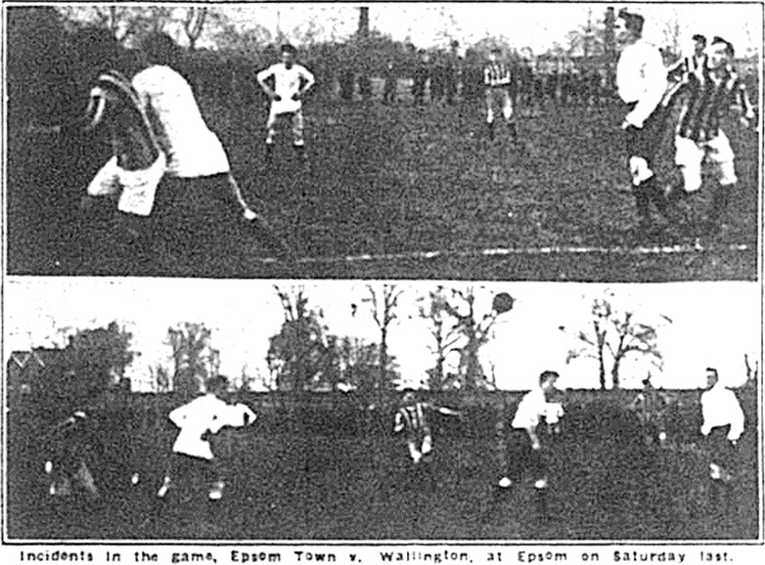
Action from the Surrey Junior Cup 5th round tie in January 1923 at Horton Hospital Grounds

Action from our last ever Intermediate match, the Sutton Hospital Cup Final in May 1924

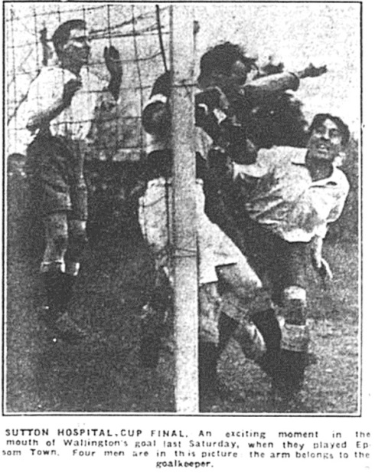
As we were by now a Senior club it seems a bit odd that we would host them some five years later in a pre-Christmas friendly at West Street. We put a fairly strong side in the field, although some of our regulars were excused, and we received a shock, losing 3-4.

Back then they had moved from the centre of town to play at Plough Lane, the future home of the Post Office Engineers. The club did not survive for much longer though and by the early thirties they had vacated Plough Lane, never to return. We would play there on many occasions in the future, but never against Wallington.

Waltham Forest: Played 1 - W0 D0 L1 - F0 A1 - PPG - 0.00

No connection to Waltham Abbey who play nearby, we met Waltham Forest in the Isthmian League Cup, while we were struggling in Division One South and they were doing likewise in Division One North.

It could arguably have been billed as a battle of which were the worst club at that time and we claimed the prize, contriving to concede an 87th minute goal at Merland Rise, which mercifully saved us all from the extra time period that would have followed!

They would improve to survive the season in 16th place, while we of course went down. However, they also left the League at the end of that season and although they returned in 2006/07, remaining for a while, they were relegated in 2014 and now ply their trade at Step Five, in the Essex Senior League. They played their matches at Wadham Lodge in Kitchener Road, Walthamstow, which brings me to…

Pennant: Played 1 - W1 D0 L0 - F2 A1 - PPG - 3.00 – Perfect

Walhamstow Pennant: Played 1 - W0 D0 L1 - F1 A3 - PPG - 0.00

These two clubs were the direct ancestors of Waltham Forest. We met Pennant in a London Senior Cup tie back in December 1983, when our promotion winning team edged them out 2-1 with the aid of an extra time own goal in the London Senior Cup, earning us a trip to Bromley I recall.

In January 1992 we made our only visit to Wadham Lodge for a London Challenge Cup First Round tie with the by now renamed Walthamstow Pennant on a Thursday night, and we fielded our entire Reserve squad, unsurprisingly losing 3-1 there with Martin Taylor scoring our goal in the first half. Makes you wonder why we entered!

From behind the goal
Bedfont Sports 1-3 Epsom & Ewell
Combined Counties League - Premier Division - Wednesday 15th March 2017

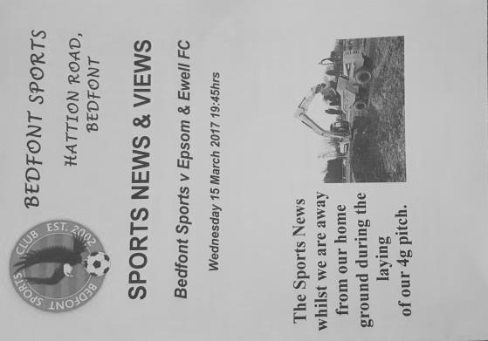
Salts rally in second half to see off Sports

The Orchard, home of Bedfont and Feltham has seen some strange goings on this season and that's just on the three occasions that we have visited!

We have played three different teams here after many seasons without paying a visit and this time our opponents were Bedfont Sports, whose own pitch is being transformed just a few yards beyond the far touchline if you looked from the clubhouse end. So far we have witnessed a match here with 11 goals in one net, another where a major defensive shortage required us to play our right winger at centre half and this time we had a player scoring at both ends and an even more unusual incident when the referee appeared to send a spectator off!

I will get to that later but it is most important to report that we have now recorded three wins out of three here this season and this was also our sixth match without defeat at Bedfont Sports since they were promoted to our division. In the meantime we extended our unbeaten run to ten matches but it didn't look that likely to happen at half time.

We started with just the one change to the team that won at home to Bedfont and Feltham last Tuesday with Matt Ferdinando coming in for the absent Jason Nwachukwu, while Captain Dan Dean was also unavailable so Matt Farrell retained the armband for this match as Dean had been rested against Bedfont & Feltham.

Unfortunately, and for the second week in a row we were slow starters. In the opening minutes a Rob Hendry free kick avoided everyone and went out for a goal kick while in response the home side drilled a free kick into our wall but there was little else to report. We almost scored in the 21st minute when a curling right wing cross eluded Matt Ferdinando at full stretch but were behind in the 23rd after a left wing cross was headed back across goal for a close range finish from the home team's Captain Billy Jeffrys, although Michael Eacott nearly kept it out and the ball trickled almost apologetically over the line.

However, we had created little by that point and clearly needed to raise our game. We began to retain possession a little better and Jordan Gallagher delivered a free kick to the near post where James Taylor flicked the ball just inches over the bar on the volley. It was nearly a very special goal. Hendry was only just wide with a low drive from outside the area and from an Agi Panayiotou corner Farrell was unable to get his header on target.

We nearly conceded just before half time when Matt Tanton and Taylor had a miscommunication and Tanton's header was latched onto by a Bedfont striker but his shot / cross went across Eacott's goal with no one there to take advantage of it. In fact as the whistle went for half time this passage of play summed up the first half as it was hard to recall any moments of real quality,

with both keepers only being required to deal with over hit through balls.

Of course, the players must have remembered that we trailed here on the opening game of the season, yet recovered to score nine times, so a one goal deficit was able to be overcome if we could just raise our intensity a little. As one of the largest moons I have ever seen rose above the ground in the second half, a change came over our players! We opened up with more intensity from the kick off and a Panayiotou corner was met by a glancing header from Taylor, but he was unable to direct the ball on target.

The pressure continued and in the 59th minute we equalised, although there was a huge element of fortune about the goal. Gallagher made tracks down the left before laying the ball back for Tanton to deliver a dangerous cross from the left. Taylor was forward again and he flicked the ball on towards Hendry, but Jeffrys got there in front of him, the ball rebounding off his chest, completely wrong footing the keeper Kavanagh Keadell and nestling in the corner of the net. Keadell had been in goal for Spelthorne Sports at High Road back in January when we defeated them 3-2 and he was destined to concede three once again.

And we remained in the ascendency with the home team becoming more and more restricted in their attacks. Farrell set up Gallagher who cut in and unleashed a powerful low shot that pinged back across the goal off the far post, and on another day it would have fallen for the incoming Farrell to tap in, but this time the ball was just behind him. However, the ball wasn't cleared and panic ensued for a while with Reisse Griffin on the right wing battling for the ball with Bedfont's Jake Hicks in the 66th minute. They got tangled up and then it got serious as Griffin appeared to be trodden on. The referee thought about it, then checked with the Assistant before sending Hicks off for violent conduct. It looked harsh but we have certainly been on the wrong end of some of these decisions this season, and this time it was an opposition player who had to go.

What happened next was really odd. Firstly, play restarted with a Bedfont Sports free kick outside of the penalty area, even though the alleged stamp occurred in the penalty area well before any stoppage in play occurred. If that was odd, the next incident was downright bizarre as the Assistant reacted to something that was said to him and he called the Referee over who then had a few words with the "offender" at which point he departed from where he had been standing. No card was issued but it looked as though he had been sent off. My thoughts went back to a match at the same venue in 2006 where the referee on that day tried to move half a dozen of us from behind the goal and this was equally strange!

The game continued and with the extra man we just had to take advantage of the situation if we wanted to keep up our hunt for a top four finish. Fortunately we did this with two goals in three minutes. A good build up resulted in Hendry getting the ball and from just inside the box he drilled the ball across Keadell into the bottom corner of the net in the 80th minute. In the 82nd minute we caught the opposition out with a short corner as Panayiotou passed it to Ferdinando who returned it back to him and when the cross came in, Farrell had lost his man and headed the ball in from close range.

In summary, we deserved the points for stepping up a few gears in the second half but with Hartley Wintney coming up on Saturday and both our 10 game unbeaten run and our 17 match unbeaten home League record on the line we will not be able to start so slowly if we want to keep those records intact. However, credit is due to our lads for fighting back to claim the points, and no one got booked either which was a pleasant bonus for our Treasurer!

Epsom and Ewell: Michael Eacott, Adam Heagney, Matt Tanton, James Taylor,
Craig Hastings, Savvas 'Agi' Panayiotou, Jordan Gallagher, Matt Farrell (c), Rob Hendry,
Matt Ferdinando, Reisse Griffin

Sub: Alex McKay for Panayiotou (84)

Combined Counties League Premier Division
Opponents All-time Records
incl Wednesday 15th  February | P | W | D | L | F | A | PPG | GD | Best  Win | Worst  Loss
Bedfont & Feltham | 2 | 2 | 0 | 0 | 13 | 3 | 3.00 | +10 | 9-2 | X
Spelthorne Sports* | 7 | 5 | 2 | 0 | 20 | 10 | 2.43 | +10 | 6-2 | X
Sutton Common Rovers | 12 | 9 | 2 | 1 | 30 | 14 | 2.42 | +16 | 4-0 | 1-4
Abbey Rangers | 4 | 3 | 0 | 1 | 11 | 4 | 2.25 | +7 | 7-1 | 2-3
Horley Town | 29 | 20 | 5 | 4 | 65 | 30 | 2.24 | +35 | 6-0 | 1-3
Bedfont Sports | 11 | 7 | 2 | 2 | 21 | 12 | 2.09 | +9 | 5-1 | 0-4
Colliers Wood United | 22 | 14 | 2 | 6 | 45 | 33 | 2.00 | +12 | 4-0 | 0-5
Westfield | 20 | 12 | 3 | 5 | 42 | 32 | 1.95 | +10 | 6-1 | 0-4
Guildford City | 18 | 11 | 1 | 6 | 35 | 22 | 1.89 | +13 | 5-1 | 1-5
Farnham Town | 14 | 8 | 2 | 4 | 25 | 23 | 1.86 | +2 | 3-1 | 1-4
Knaphill | 7 | 4 | 1 | 2 | 15 | 8 | 1.86 | +7 | 4-0 | 1-2
Badshot Lea | 19 | 9 | 3 | 7 | 39 | 36 | 1.74 | +3 | 4-1 | 0-4
Hanworth Villa | 17 | 8 | 4 | 5 | 38 | 27 | 1.65 | +11 | 5-0 | 1-4
Walton & Hersham | 52 | 25 | 11 | 16 | 105 | 99 | 1.65 | +6 | 8-0 | 1-9
Raynes Park Vale | 28 | 13 | 7 | 8 | 59 | 38 | 1.64 | +21 | 6-1 | 0-2
Camberley Town* | 89 | 38 | 22 | 28 | 158 | 123 | 1.52 | +35 | 9-1 | 0-4
Hartley Wintney | 11 | 4 | 3 | 4 | 26 | 20 | 1.36 | +6 | 5-0 | 2-4
Windsor | 49 | 19 | 12 | 18 | 90 | 90 | 1.41 | 0 | 4-0 | 0-6
Chertsey Town | 49 | 19 | 5 | 25 | 75 | 87 | 1.27 | -12 | 3-0 | 0-7
North Greenford United | 11 | 3 | 2 | 6 | 15 | 20 | 1.00 | -5 | 3-0 | 1-4
CB Hounslow United | 3 | 1 | 0 | 2 | 4 | 7 | 1.00 | -3 | 2-0 | 1-5
AFC Hayes | 10 | 2 | 3 | 5 | 18 | 18 | 0.90 | 0 | 7-0 | 0-3
* includes one abandoned match v Camberley and one loss on penalties v Spelthorne

Salts Super Six Predictor
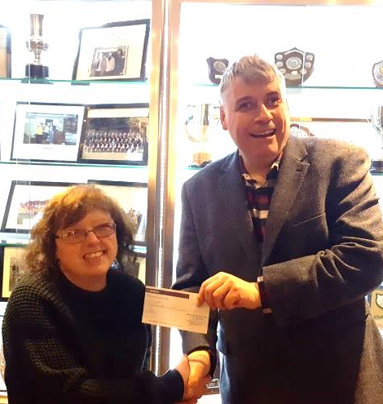
The Salts Super Six Predictor is live again for today’s match and the tickets are on sale at today’s game to the left of the gate. The matches are to be played today.

The jackpot was claimed twice recently and Rita Christian and Russell Bateup were the two winners (pictured above with Steve Dyke and Richard Lambert) but it is already up to £155 so it may not be long before it is getting large again!

The competition is easy to play! To win, you simply need to predict the results of six matches correctly from the three options, fill in the form and make sure it is back with our seller before the deadline on the ticket. The latest fixtures are shown below.

If you are a club regular, you just need to place your name on the sheet, although if you aren’t, then we’ll need a contact number from you too. We will announce any winners on the website within three working days, so don’t worry, we won’t miss you!

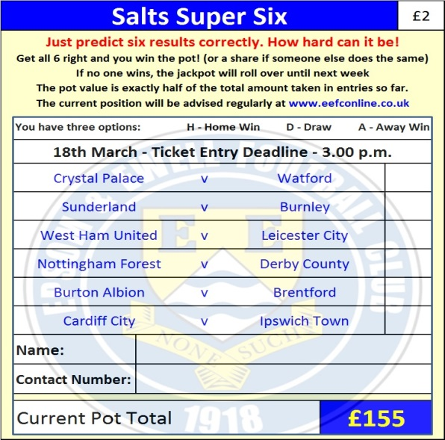
Please note that if there is more than one winner, the prize pot would be shared between them. All you need to do now is have a go, as many times as you like!

Good luck!

Combined Counties League – Premier Division
Saturday, 18th March 2017 - Kick-off 3.00 p.m.

Epsom and Ewell  (Royal Blue & White hoops) | V |  | Hartley Wintney  (All Orange)
Squad | NUMBERS |  | Squad
Michael Eacott |  |  | Paul Strudley
Adam Heagney |  |  | Jake Maddock
Matt Tanton |  |  | Marc Vockins
James Taylor |  |  | Adam New
© Dan Dean |  |  | Dec Shuttleworth
Savvas ‘Agi’ Panayiotou |  |  | Steve Noakes
Jordan Gallagher |  |  | Liam Eagle
Matt Farrell |  |  | Shane Hollamby
Rob Hendry |  |  | Jack French
Matt Ferdinando |  |  | Louie Paget
Reisse Griffin |  |  | Tom Walsh
Jason Nwachukwu |  |  | Luke Perkins
Craig Hastings |  |  | Steve Duff
Daryl Cooper-Smith |  |  | Dean Stow
Alex McKay |  |  | Ian Jones
Ali Dewar |  |  | Steve Laidler
Alistair Turpie |  |  | Ross Cook
Matt Smith |  |  | Sam Argent
Glyn Mandeville | MANAGER |  | Dan Brownlie /  Anthony Millerick
Matt Smith | ASSISTANT
Steve Eacott / Alex McKay/  Jimmy Hendry | COACHES / PHYSIO
REFEREE: L. Pinto Nunes
ASSISTANTS: J.Oxenham, P.Crichlow

OUR NEXT VISITORS TO HIGH ROAD
Windsor F.C.
Combined Counties League
Premier Challenge Cup – Semi Final
Tuesday 21st March 2017 – 7.45 p.m.

